# ABC’s Inventory Management System

## Test Script

|  |  |  |  |  |  |
| --- | --- | --- | --- | --- | --- |
| **Test Name** | | Test Search Product Using Unknown Product Item Code (Test Case SPT004) | | | |
| **Use Case Tested** | | Search Product | | | |
| **Test Description** | | This test tests if the system can retrieve product item details and contents in each location using a unknown product item. | | | |
| **Pre-Conditions** | | N/a | | | |
| **Post-Conditions** | | The alert will be popped up to display the message that notify user the searching product item code does not exist in system. | | | |
| **Notes** | | This test assumes that the user try to search the product item code randomly. | | | |
| **Result (Pass/Fail/Warning/ Incomplete)** | | Pass | | | |
|  | **Test Step** | | **Expected Test Results** | **P** | **F** |
| 1. | Open the ABCInventoryClient.exe file | | ABCInventoryClient system launches. | P |  |
| 2. | Type in the random product item code in the Product Item Code field of the system. | | System waits for the user to hit enter or click on the ‘Search’ button. | P |  |
| 3. | Hit enter or click on the ‘Search’ button. | | An alert message will be displayed to let user know the searching product item does not exist in system. | P |  |

|  |  |  |  |
| --- | --- | --- | --- |
| **Test Data Table** | | | |
|  | **1** | **2** | **3** |
| **Product Item Code** | SJSAJO | S23022 | S2AB |

# Result Screenshots

The screenshots of the result on each test step for each data set are given below:

## Data Set 1

**Step 1**

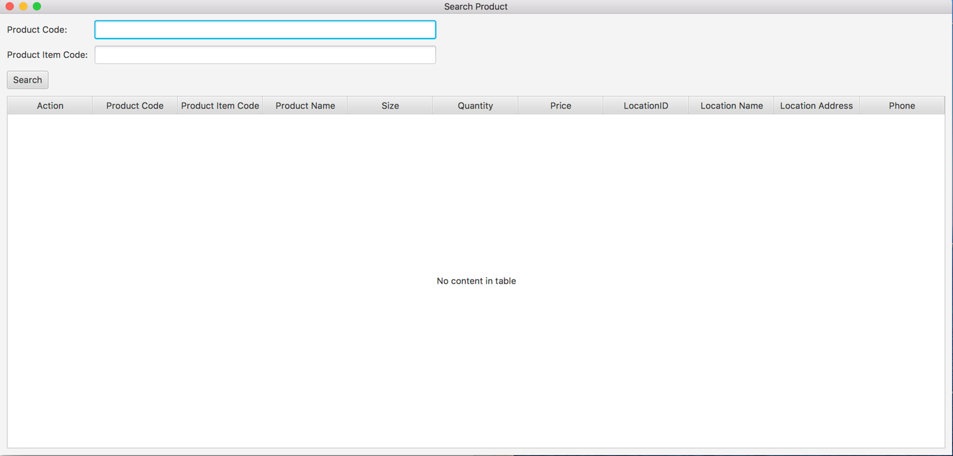

**Step 2**

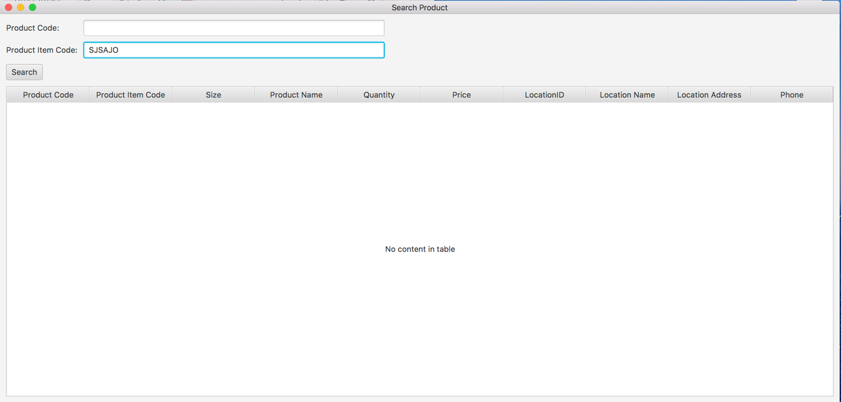

**Step 3**

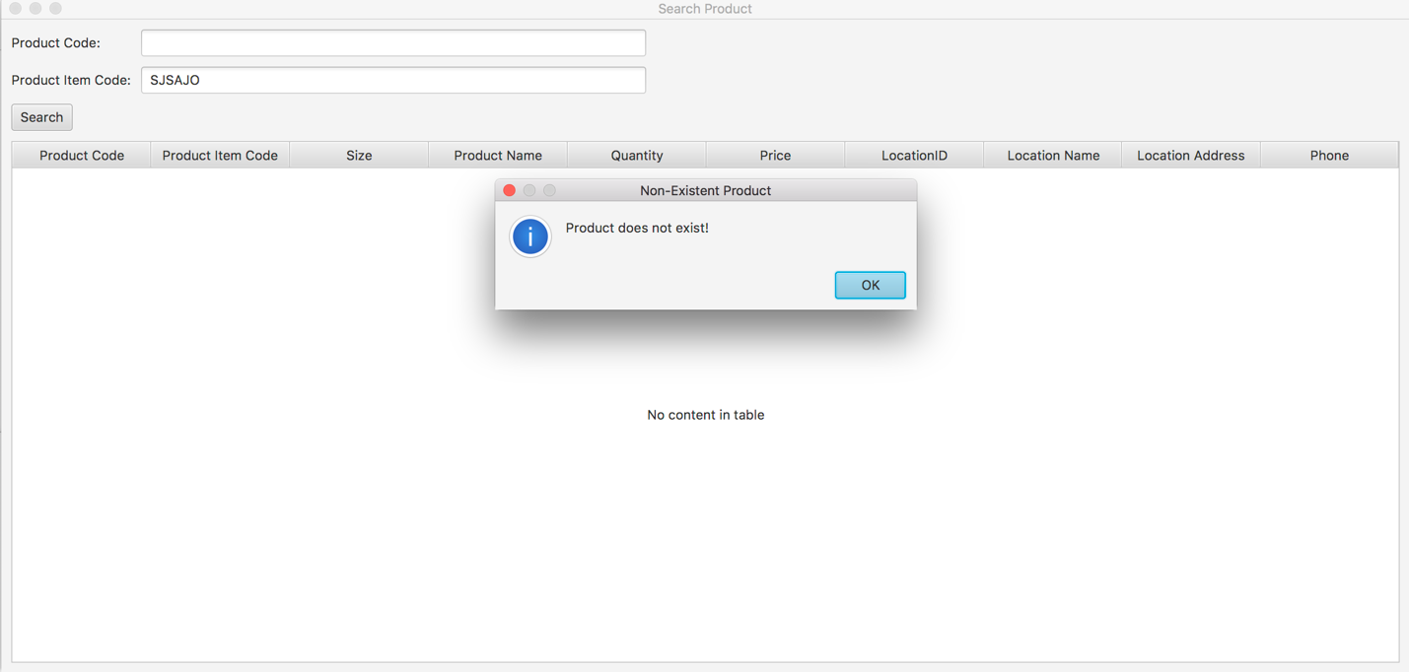

## Data Set 2

**Step 1**



**Step 2**

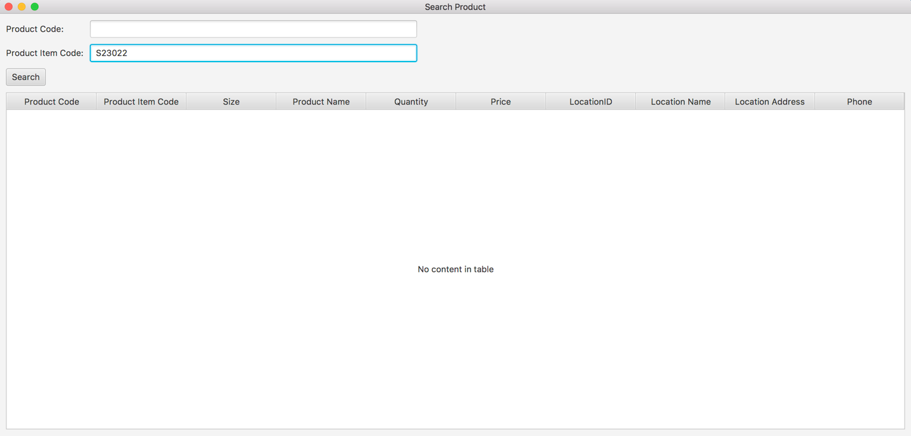

**Step 3**

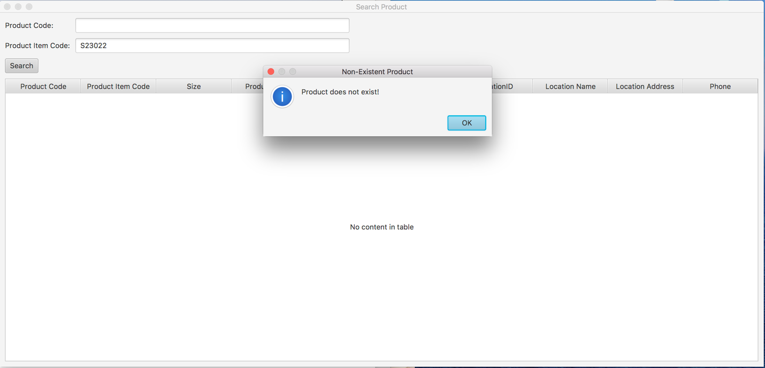

## Data Set 3

**Step 1**



**Step 2**

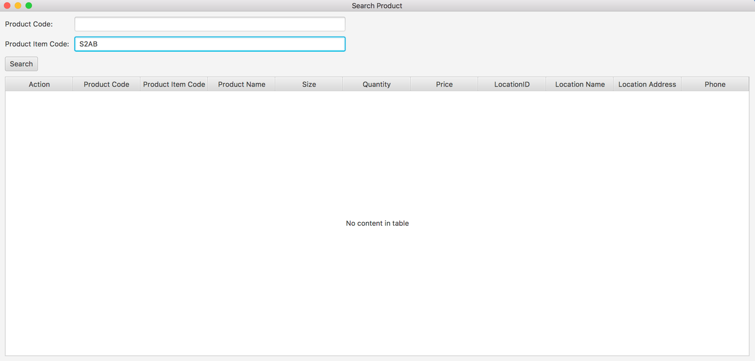

**Step 3**

